**The Shrew Caravan:**

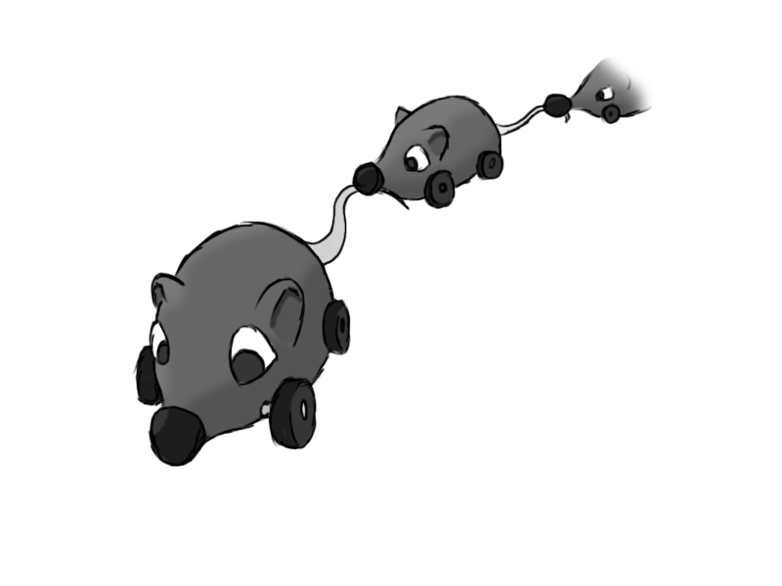

Figure - Enemy: Shrew Caravan

**Brief Synopsis**

The shrew caravan consists of a mother shrew, and several smaller baby shrews. Each baby shrew has the tail of the shrew in front in its mouth, creating a chain. Based off wheeled toys that are dragged around by children, these will be weak enemies, but the large size and unpredictability when hit will pose a challenge. When one is hit, the baby shrews behind it detach from each other, and race off in random directions, bouncing off walls. Attacking them from the last baby to the mother will prevent the area being swarmed, whereas the scythe can cut down the numbers quickly.

**Variants.**

Variants of the mother shrew would make it so that she targets the player, pathfinding towards them while moving at a set speed. This is triggered by the player moving within range, and the mother will return to the closest point on her path once the player leaves. A further variant would not deactivate once the player is out of range. These could be differentiated by colour, using white, brown, and black shrews.

**AI**

The mother will follow a pre-set path around the area, via spline paths. The baby shrews will follow, attached to each other by the tail. When a shrew dies, the one behind charges forwards, and sets a trigger to the one behind to do the same, until the last shrew is reached. Due to this, each shrew needs to know which shrew is behind it. They will charge forwards in random directions, bouncing off walls.

**Animations**

The shrew will not need much in the way of animations, as it damages the player on contact.

**Move:**

* Wheels on the shrew rotate forwards, propelling it along, with the occasional wobble to simulate loss of balance.

**Rotate:**

* The shrew will rotate back and forth before picking an angle at which to move at. The wheels will rotate in opposite directions.

**Death:**

* The shrew will fall on its side before exploding.

**Average Size**

